Spatiotemporal Change Detection and Analysis in Remote Sensing Imagery

# Raunak Sarbajna, Dr. Sujing Wang

## Department of Computer Science, Lamar University

# Abstract

The purpose of this study is to detect spatiotemporal changes within sequential maps. Change analysis models are essential in understanding larger patterns and trends in multifaceted, time-series geographic data. All polygons under consideration are closed. spatial, georeferenced sets. The change detection is done through three primary set operations: union, intersection and erase. We initially generate polygons, by creating convex hulls from point data. Then, we calculate area of each individual polygon within each map layer. We then execute a union operation and calculate area. The union layer now contains the original areas of both layers and the areas of the overlapping polygons - we now need to query them properly to prepare for calculating the change percentage and tabulating intersection. To outline the polygon, we examine several different methods: (1) we find features common to either of the layers but not both, essentially performing a symmetrical difference, (2) we erase the larger of the polygons from the smaller, thus retaining only the growth, and do vice-verse for shrinking, (3) we perform simple intersection and then invert selection to get changed regions. All operations are performed using the ArcGIS/ArcPy toolkit. Our sample data for this process were shapefiles of drought intensity and impact from the North American Drought Portal and Twitter emotion measurements created through sentiment analysis.

# Introduction

Analyzing change in spatial data is critical for many applications including developing early warning systems that monitor environmental conditions, detecting political unrest and crime monitoring.

Change analysis models are essential in understanding larger patterns and trends in multifaceted, time-series geographic data. The purpose of this study is to detect spatiotemporal changes in land use within sequential (time-series) maps. Changes in land use can be categorized by the complex interaction of structural and behavioral factors associated with technological capacity, demand, and social relations that affect both environmental capacity and the demand, along with the nature of the environment of interest.

The goal of this research project is to detect and analyze how the patterns of features change over time and space in spatiotemporal land use datasets. All polygons under consideration are closed spatial georeferenced sets, rather than raster imagery.

There are two different datasets under consideration here. First is the Spatiotemporal Drought Datasets from the North American Portal: <https://www1.ncdc.noaa.gov/pub/data/nidis/shapefiles/>. Second is user generated maps of sentiment analysis performed on twitter data, which have been geolocated to a reasonable accuracy level. This second data source required a lot of preprocessing which has been explained in section 4.2

The spatial reference for the Drought shapefiles can be seen in figure 1, and for the twitter data can be seen in figure 2.

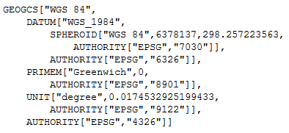

Figure 1 Spatial Reference for Drought data

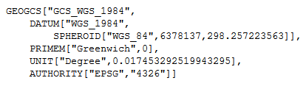

Figure 2 Spatial reference for Twitter data

The layer definition for the data sets can be seen in tables 1 and 2.

Table 1 Layer Specification for Drought data

|  |  |  |  |
| --- | --- | --- | --- |
| Name | Type | Width | Precision |
| FIPS_ADMIN | String | 4 | 0 |
| GMI_ADMIN | String | 7 | 0 |
| ADMIN_NAME | String | 42 | 0 |
| FIPS_CNTRY | String | 2 | 0 |
| GMI_CNTRY | String | 3 | 0 |
| CNTRY_NAME | String | 40 | 0 |
| POP_ADMIN | Integer | 9 | 0 |
| TYPE_ENG | String | 26 | 0 |
| TYPE_LOC | String | 50 | 0 |
| SQKM | Real | 16 | 2 |
| SQMI | Real | 16 | 2 |
| COLOR_MAP | String | 2 | 0 |

Table 2 layer Specification for Twitter Emotion data

|  |  |  |  |
| --- | --- | --- | --- |
| Name | Type | Width | Precision |
| long | Real | 24 | 15 |
| lat | Real | 24 | 15 |
| id | Integer | 9 | 0 |
| dnstyTh | Real | 24 | 15 |
| avgScor | Real | 24 | 15 |
| numTwts | Integer | 9 | 0 |
| stdDev | Real | 24 | 15 |
| batchNm | Integer | 9 | 0 |
| geoData | String | 80 | 0 |

Our approach provides a change monitoring framework which creates a change graph that captures the changes in spatial land uses clusters and a change summarization framework that creates specific change summaries based on the change graph based on the change story types.

# Literature Review

A survey of the classical change detection algorithms can be found in the Lu et al. [3] paper and tells us that the integrated GIS and remote sensing approaches yield the best results. However, they are very sensitive to registration accuracies between images. Thus, images must be properly orthorectified and georeferenced, especially because the changes in the emotion polygons are so subtle. This assumes the emotions are to be treated as just another feature in the map, like any other category.

Since our data is primarily in an urban environment, with all the grid like rigidity that entails, it is a good idea to look at change detection algorithms optimized for urban environments. One of the hardest aspects to measure is to distinguish between change and no-change, as well as different kinds of change. Comparing image differencing, image regression, tasseled-cap transformation and chi square transformation, Ridd and Liu [3] find image differencing to be the most consistent, with a sustained overall accuracy of > 80%.

It is useful to have a programming-oriented study comparing several of the change detection algorithms using MATLAB, rather than pure application-oriented comparison, in order to have a benchmark. Minu and Shetty [5] analyzed image differencing, image ratioing, change vector analysis, tasseled cap transformation and principal component analysis for efficiency and effectiveness. Although their area of study was not urban but a variety of land use/ land cover, change vector analysis gave the best overall accuracy.

We also studied two novel methods that are recent developments and are showing promising results: Neighborhood Correlation Image and Comprehensive Change Detection Method, both of which are optimized for remote sensing imagery but can be adapted to vectorized maps without loss of generality.

The change detection model using Neighborhood Correlation Image (NCI) logic works because of the obvious fact that the same geographic area (e.g., a 3x3 pixel window) on two dates of imagery will tend to be highly correlated if little change has occurred, and uncorrelated when change occurs [1]. Computing the piecewise correlation between two data sets demonstrates that NCIs contain change information and that NCIs may be powerful tools for change detection.

A high-performance remote sensing method called Comprehensive Change Detection Method (CCDM) integrates spectral-based change detection algorithms and a novel change model called Zone, which extracts change information from two Landsat image pairs [2]. This can be easily modified to work on the Twitter-based emotional grading maps. This method is simple, easy to operate, widely applicable, and capable of capturing anthropogenic changes like our area of interest.

# Methodology

Our initial approach to this problem was to store all shapefiles in a postgres database with a GIS addon and perform operations in python. We used psycopg2 and osgeo libraries to import, process and visualize maps. However, this lead to many problems with interconversions between georeferencing schemes, while converting from WKT geometry to PostGIS geography.

We start with basic point data, which contains latitude/longitude, along with metadata identifying value of interest, whether that is drought level or emotion value. We insert the contents of the shapefile into a PostGreSQL database using the shp2pgsql toolkit that comes along with the PostGIS extension. The results can be seen in figure 3.

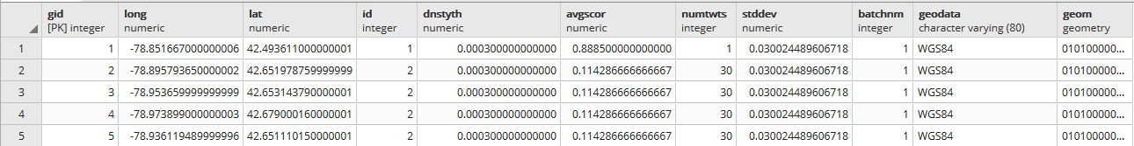

Figure 3 Twitter shapefil data inserted into Postgres db

As our framework relies on using polygonal data, we can’t use this. So we begin by creating a convex hull of points and inserting it into a new table, while preserving related metadata. Due to engine limitations, we need to be careful and insert only those convex hulls that are polygons specifically, not points or lines.

1. Our query for this purpose was:

*INSERT INTO public.june1poly (avgscor, numtwts, geodata, id, batchnm, geom) (SELECT d.avgscor, d.numtwts, d.geodata, d.id, d.batchnm, ST_ConvexHull(ST_Collect(d.geom)) FROM public."2014-06-01 " AS d GROUP BY (d.id, d.avgscor, d.numtwts, d.geodata, d.batchnm) HAVING ST_GeometryType(ST_ConvexHull(ST_Collect(d.geom))) = 'ST_Polygon')*

Where *2014-06-01 "* was the name of our original table and “*june1poly”* our new polygon table.

1. Then we insert the centroid of each polygon into the table using the query:

*UPDATE public.june1poly SET centroid=ST_Centroid(geom)*

1. We repeat this process for every shapefile needed.

Next we run our change predicates, which include:

1. S-Continuing (c,m) Agreement (c,m) ≥ 0.8
2. B-Continuing(c,b) Oap (c,b) ≥ 0.8
3. Growing(c,m) Contaiverlnment (c,m) ≥ 0.9
4. Shrinking(c,m) ↔ Growing (m,c)
5. Disappearing(c)↔ ∃i (belong-to(c,i)
6. Novel (c) ↔ ∃i (belong-to(c,i) and (i=1 or not(B-Continuing(c,i-1))
7. Shifting

Which are defined as:

𝐴𝑔𝑟𝑒𝑒𝑚𝑒𝑛𝑡 (𝑐, 𝑚) =

*Overlap(s,f)= area(p∩(p1∪…∪pm))/area(p)*

We will demonstrate three of these predicates here.

* To detect polygons that are increasing in size, we check for similar IDs, intersection and then the rate of overlap. Our query is structured as

*SELECT DISTINCT j2.* FROM public.june1poly j1, public.june2poly j2*

*WHERE ST_INTERSECTS(j1.geom, j2.geom) AND*

*(ST_AREA(ST_INTERSECTION(j2.geom, j1.geom))/st_area(j2.geom)) > .85*

* To detect polygons that are shrinking in size, we check for similar IDs, and lower rates of overlap. This can be modified based on need.

*SELECT DISTINCT j2.* FROM public.june1poly j1, public.june2poly j2*

*WHERE ST_INTERSECTS(j1.geom, j2.geom) AND*

*(ST_AREA(ST_INTERSECTION(j2.geom, j1.geom))/st_area(j2.geom)) < .25*

* To detect polygons that have shifted we compare their centroids and check if they have moved over 75km. Remember these polygons are created through a convex hull of points, which cannot ensure the centroid will lie within the polygon itself. Which is why we are taking a sufficiently large bounding value for the polygon.

*SELECT ST_Distance_Spheroid(j1.centroid, j2.centroid,*

*'SPHEROID["WGS 84",6378137,298.257223563]'),*

*j1.id FROM public.june1poly j1, public.june2poly j2*

*WHERE j1.id = j2.id AND*

*ST_Distance_Spheroid(j1.centroid, j2.centroid, ‘SPHEROID["WGS 84",6378137,298.257223563]') > 75000;*

A sample of what these generated maps look like can be found in figure 4.

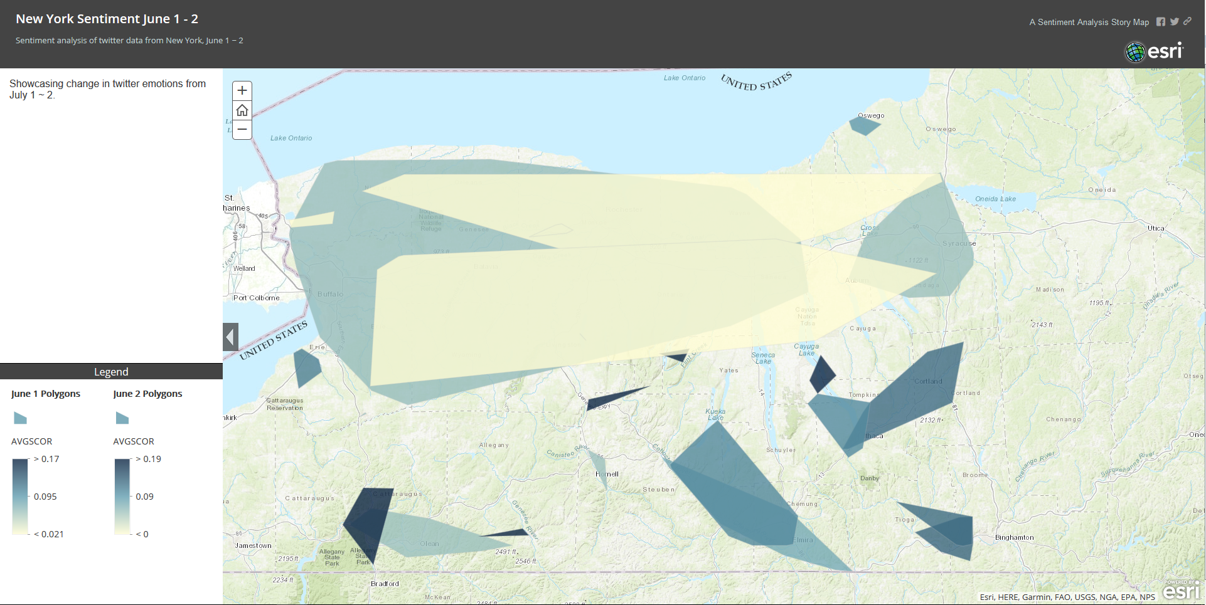

Figure 4 Polygons generated from Sentiment analysis

Our next, more successful approach was done through three primary set operations: union, intersection and erase. We calculate area of each individual polygon within each map layer. We then execute a union operation and calculate area. The union layer now contains the original areas of both layers and the areas of the overlapping polygons - we now need to query them properly to prepare for calculating the change percentage and tabulating intersection. To outline the polygon, we examine several different methods: (1) we find features common to either of the layers but not both, essentially performing a symmetrical difference, (2) we erase the larger of the polygons from the smaller, thus retaining only the growth, and do vice-verse for shrinking, (3) we perform simple intersection and then invert selection to get changed regions.

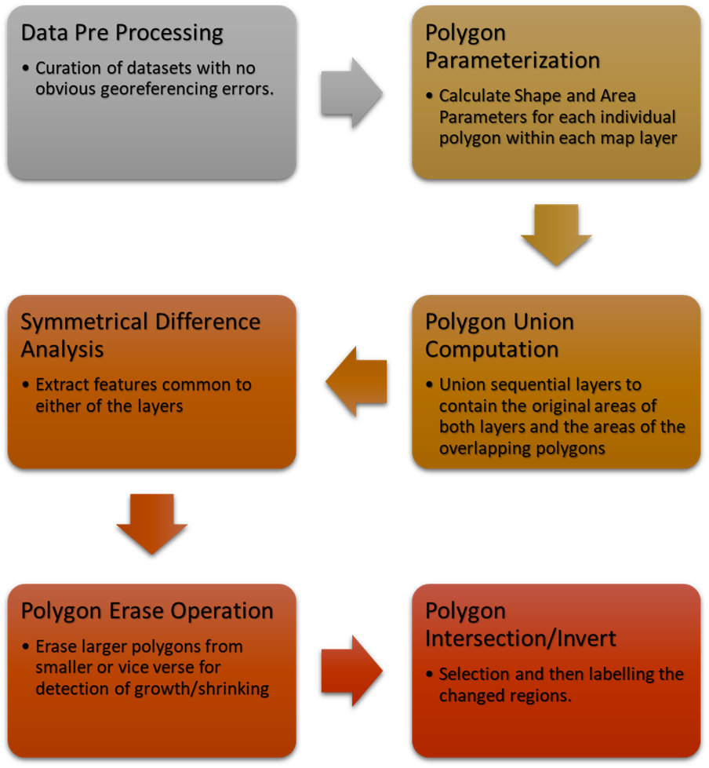

Figure 5 Map analysis methodology

Our original data source for the drought sets were defined by the USDA as seen in figure 6.

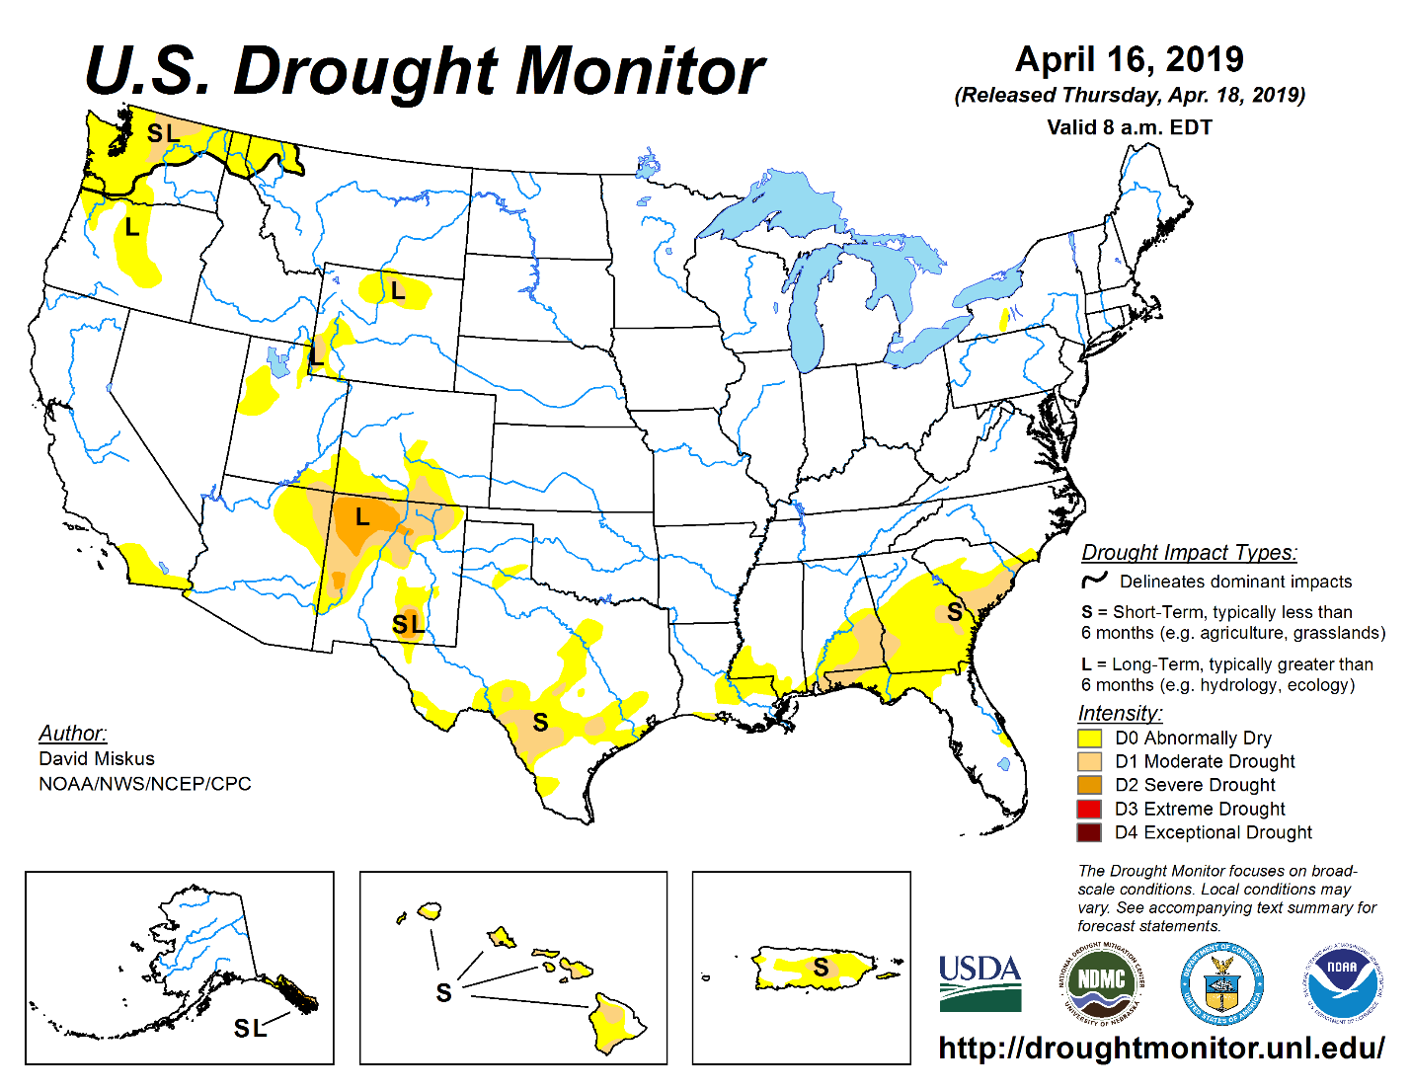

Figure 6 United Sates Drought Monitor Data

# Storytelling

The narrative generating framework called Kilimanjaro that is described in the following takes the following information as its input:

* A set of data analysis result objects DAO; DAO not only contains those objects but also their associated characteristics. For example, DAO could contain a set of spatial clusters with polygon, their average emotion scores, tweets they contain and other summaries for each spatial cluster
* An interestingness Function *i:* DAO🡪[0,+∞)
* An interestingness threshold ω—narrative will only be created for object o∈DAO such that: i(o)≥ ω.
* A region of interest *ri*.
* Other parameters that are specific to the used data analysis technique

# Results

The original polygons can be seen is Figure 7.

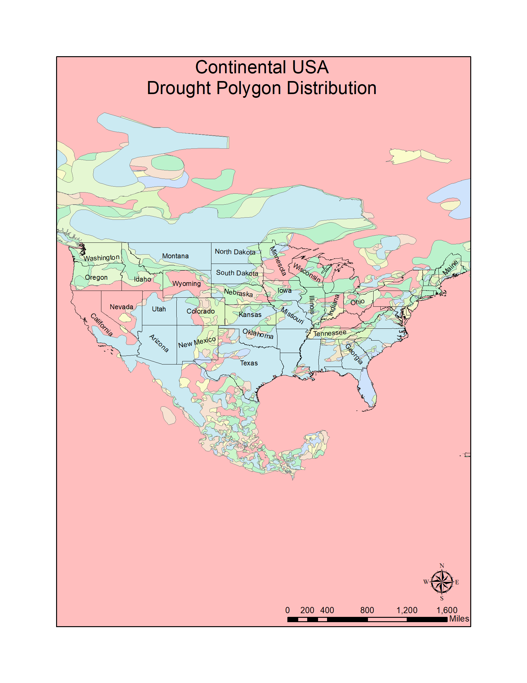

Figure 7 Drought polygon Distribution

We focus on two specific regions to highlight. First, figure 8 shows the regions where areas of drought grew in California following the wildfires in 2017.

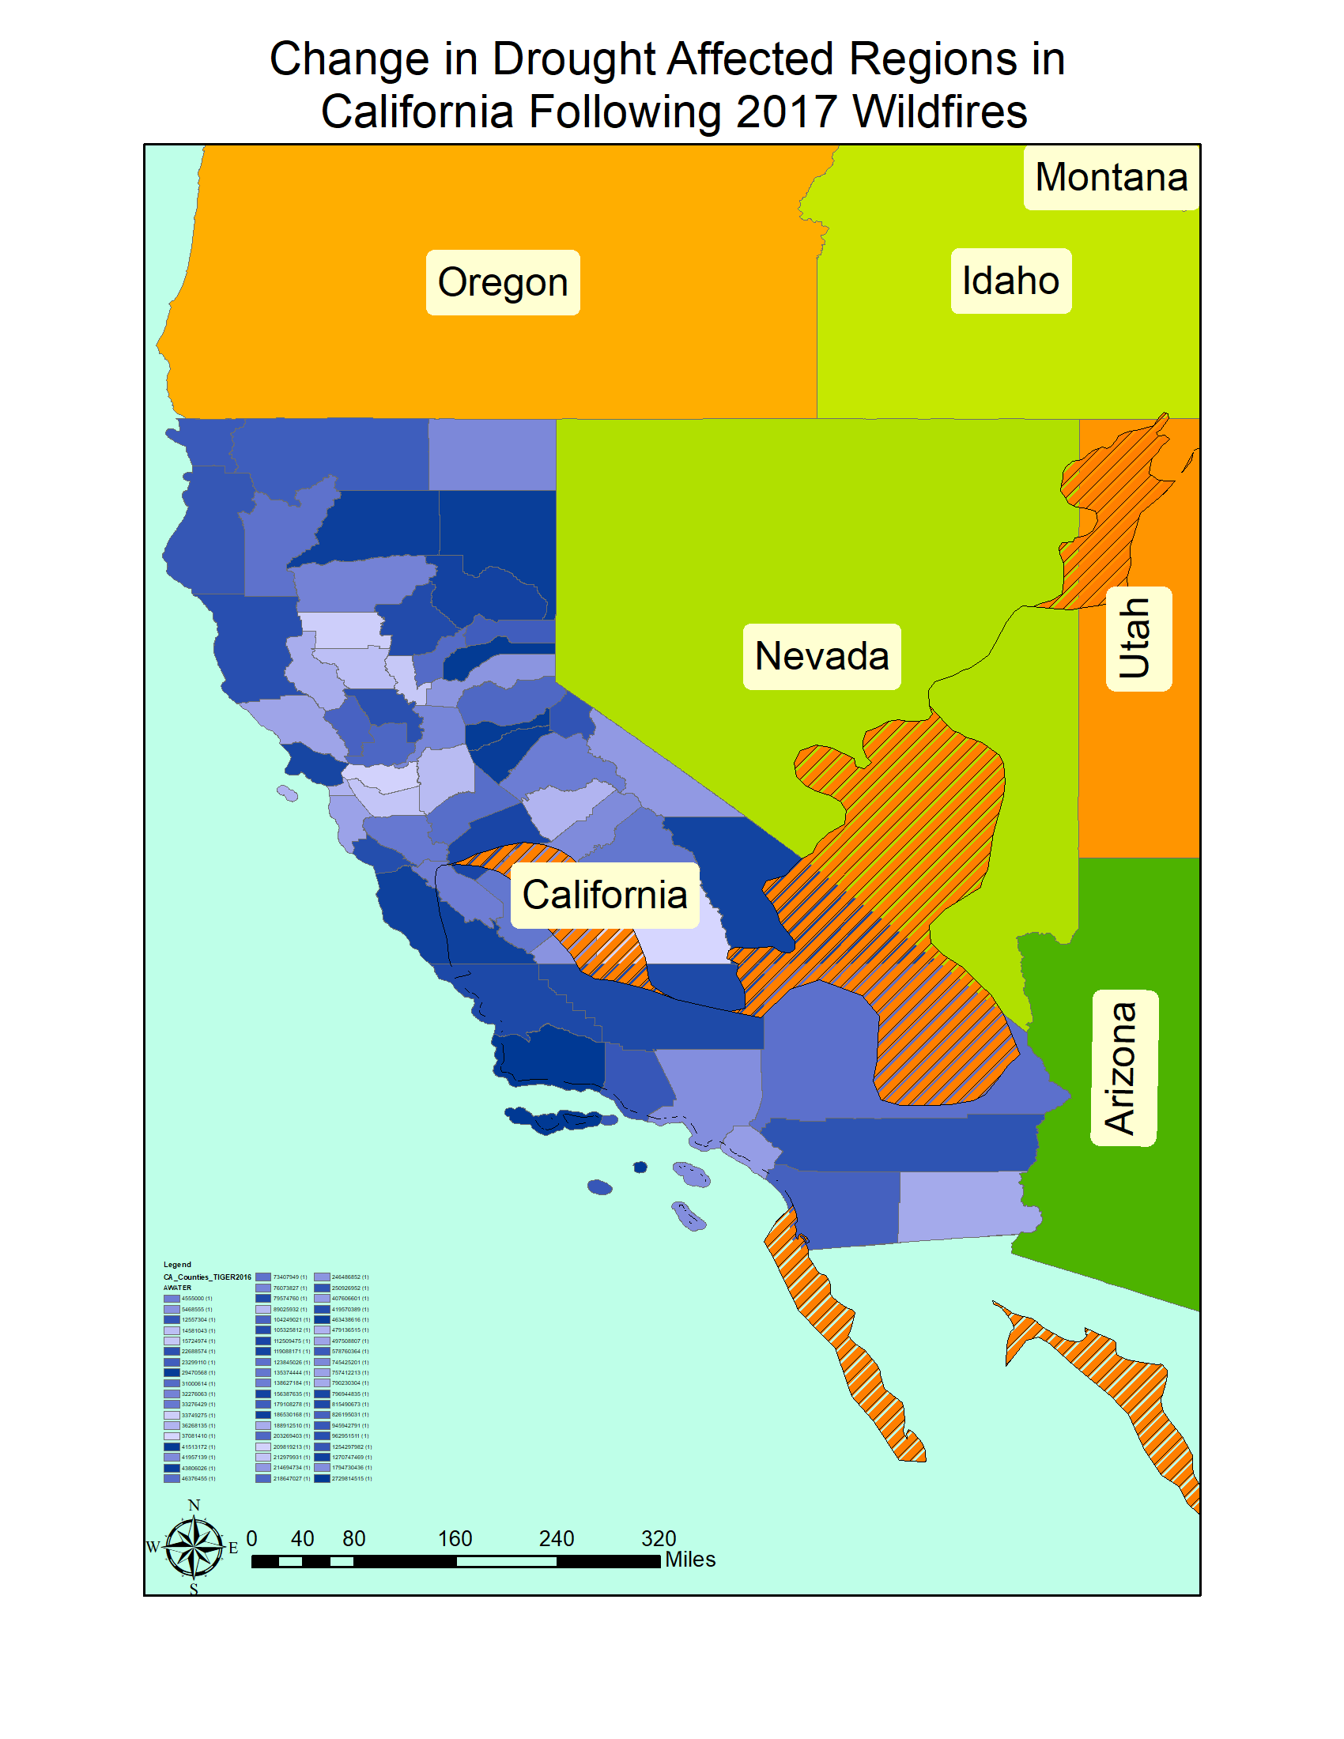

Figure 8 Change in drought affected regions in California following 2017 wildfires.

Next, we inspect the region in Texas after Hurricane Harvey. Figure 9 shows the regions where drought affected regions increased following the disaster and Figure 10 shows the regions where they decreased.

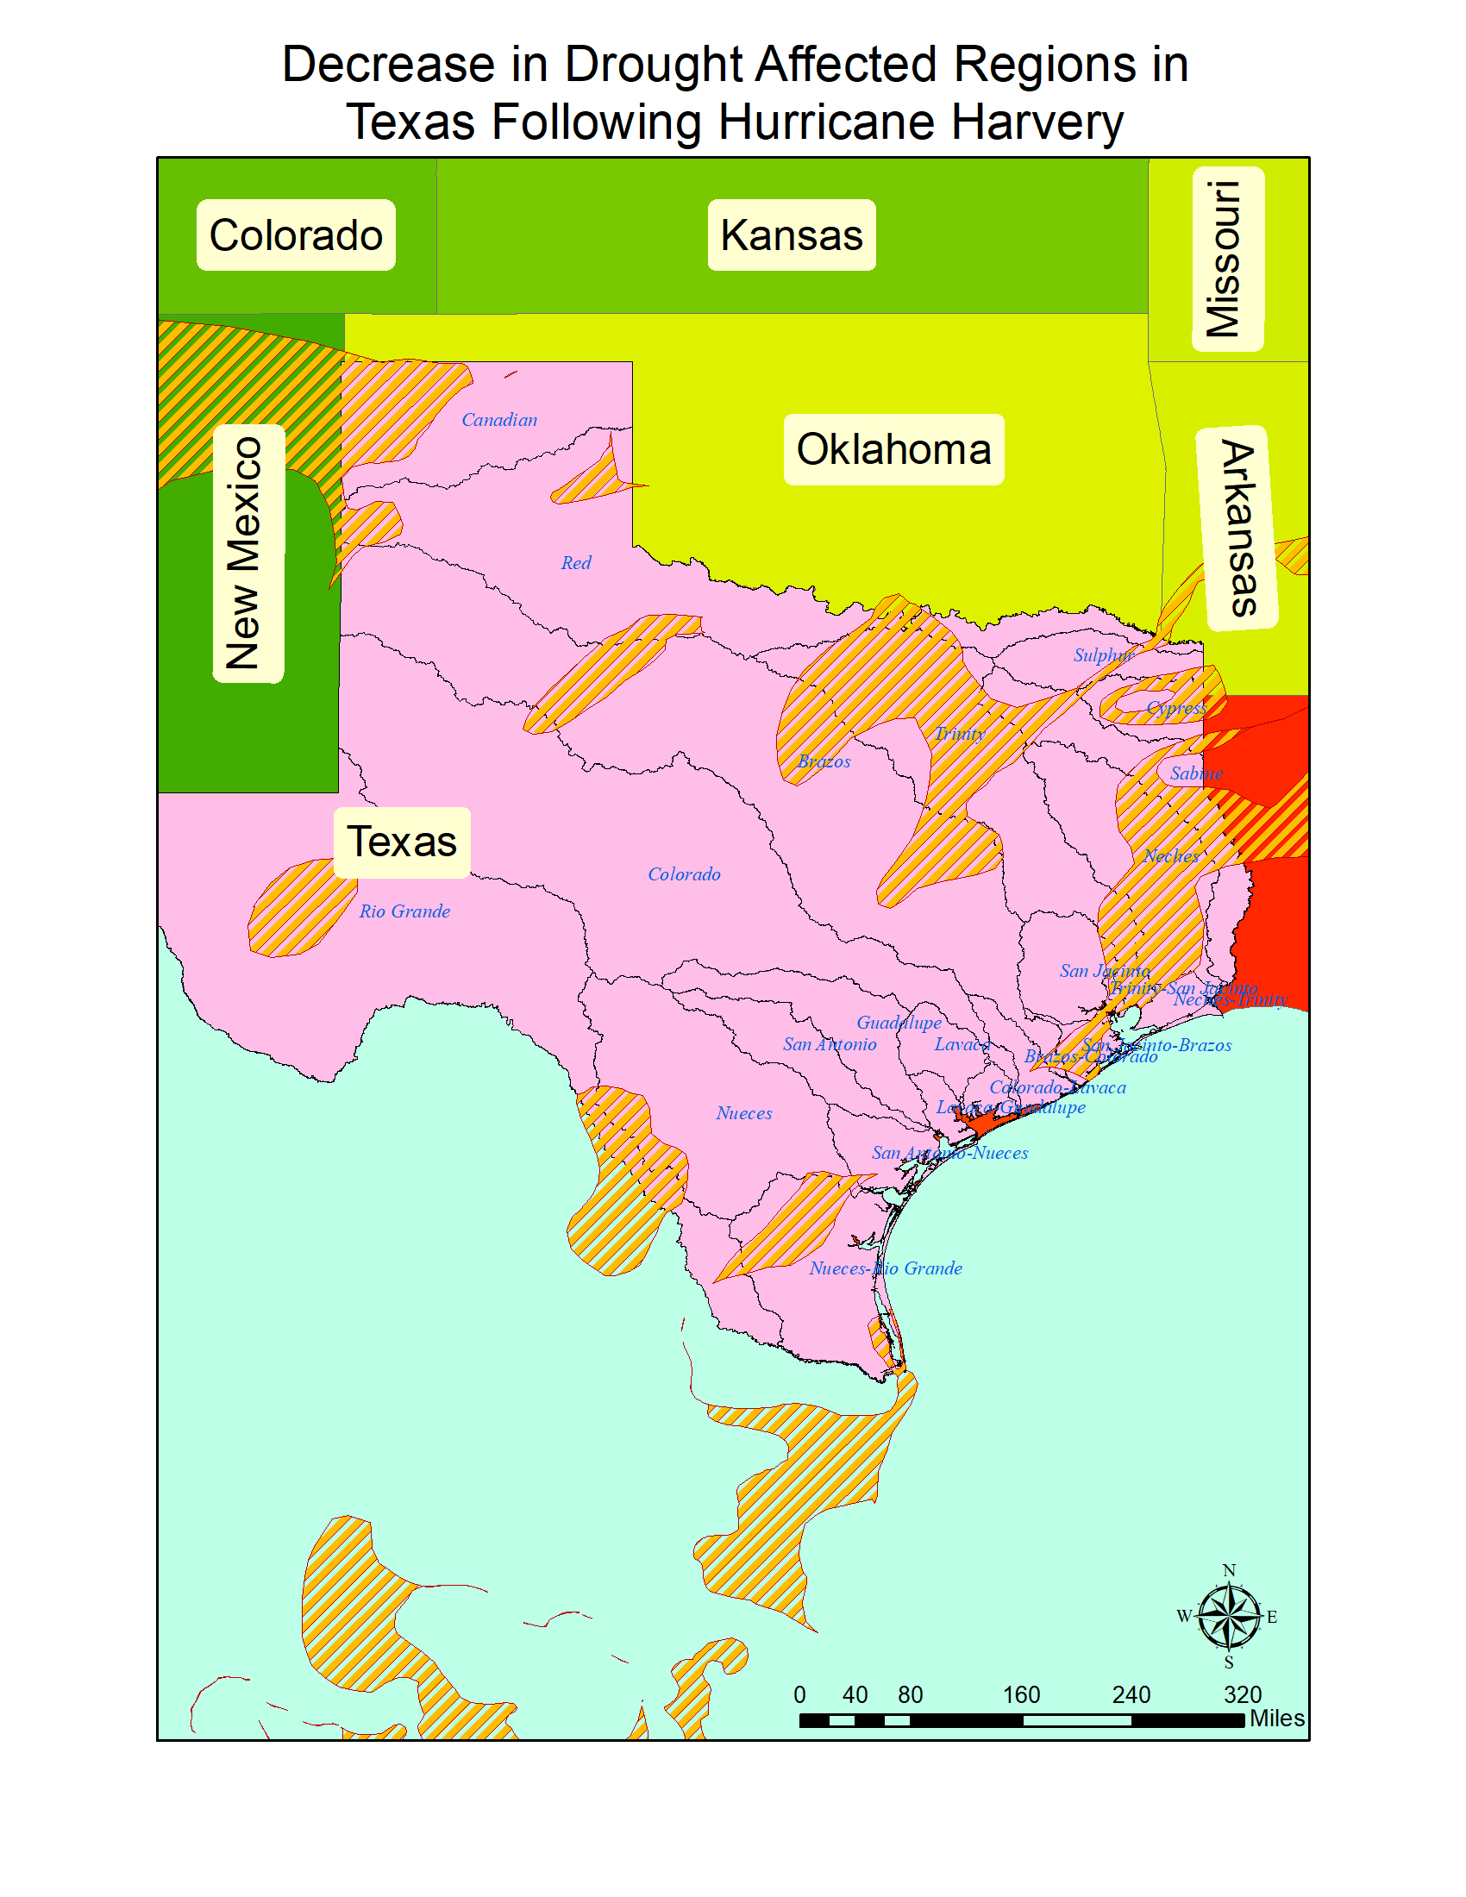

Figure 9 Decrease in Drought Affected Regions in Texas following Hurricane Harvey

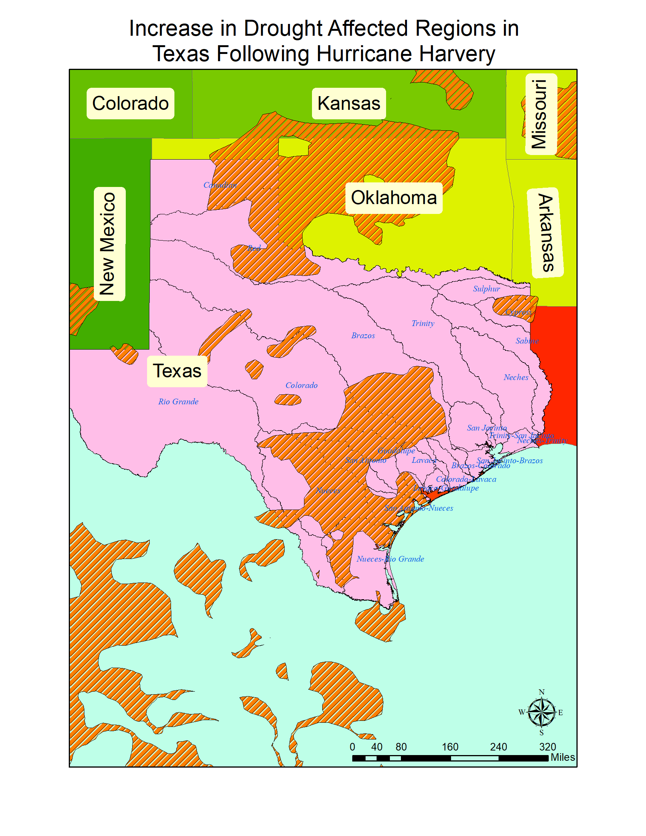

Figure 10 Increase in Drought Affected Regions in Texas following Hurricane Harvey

The results from the analyzing the twitter emotion maps can be seen in Figure 11.

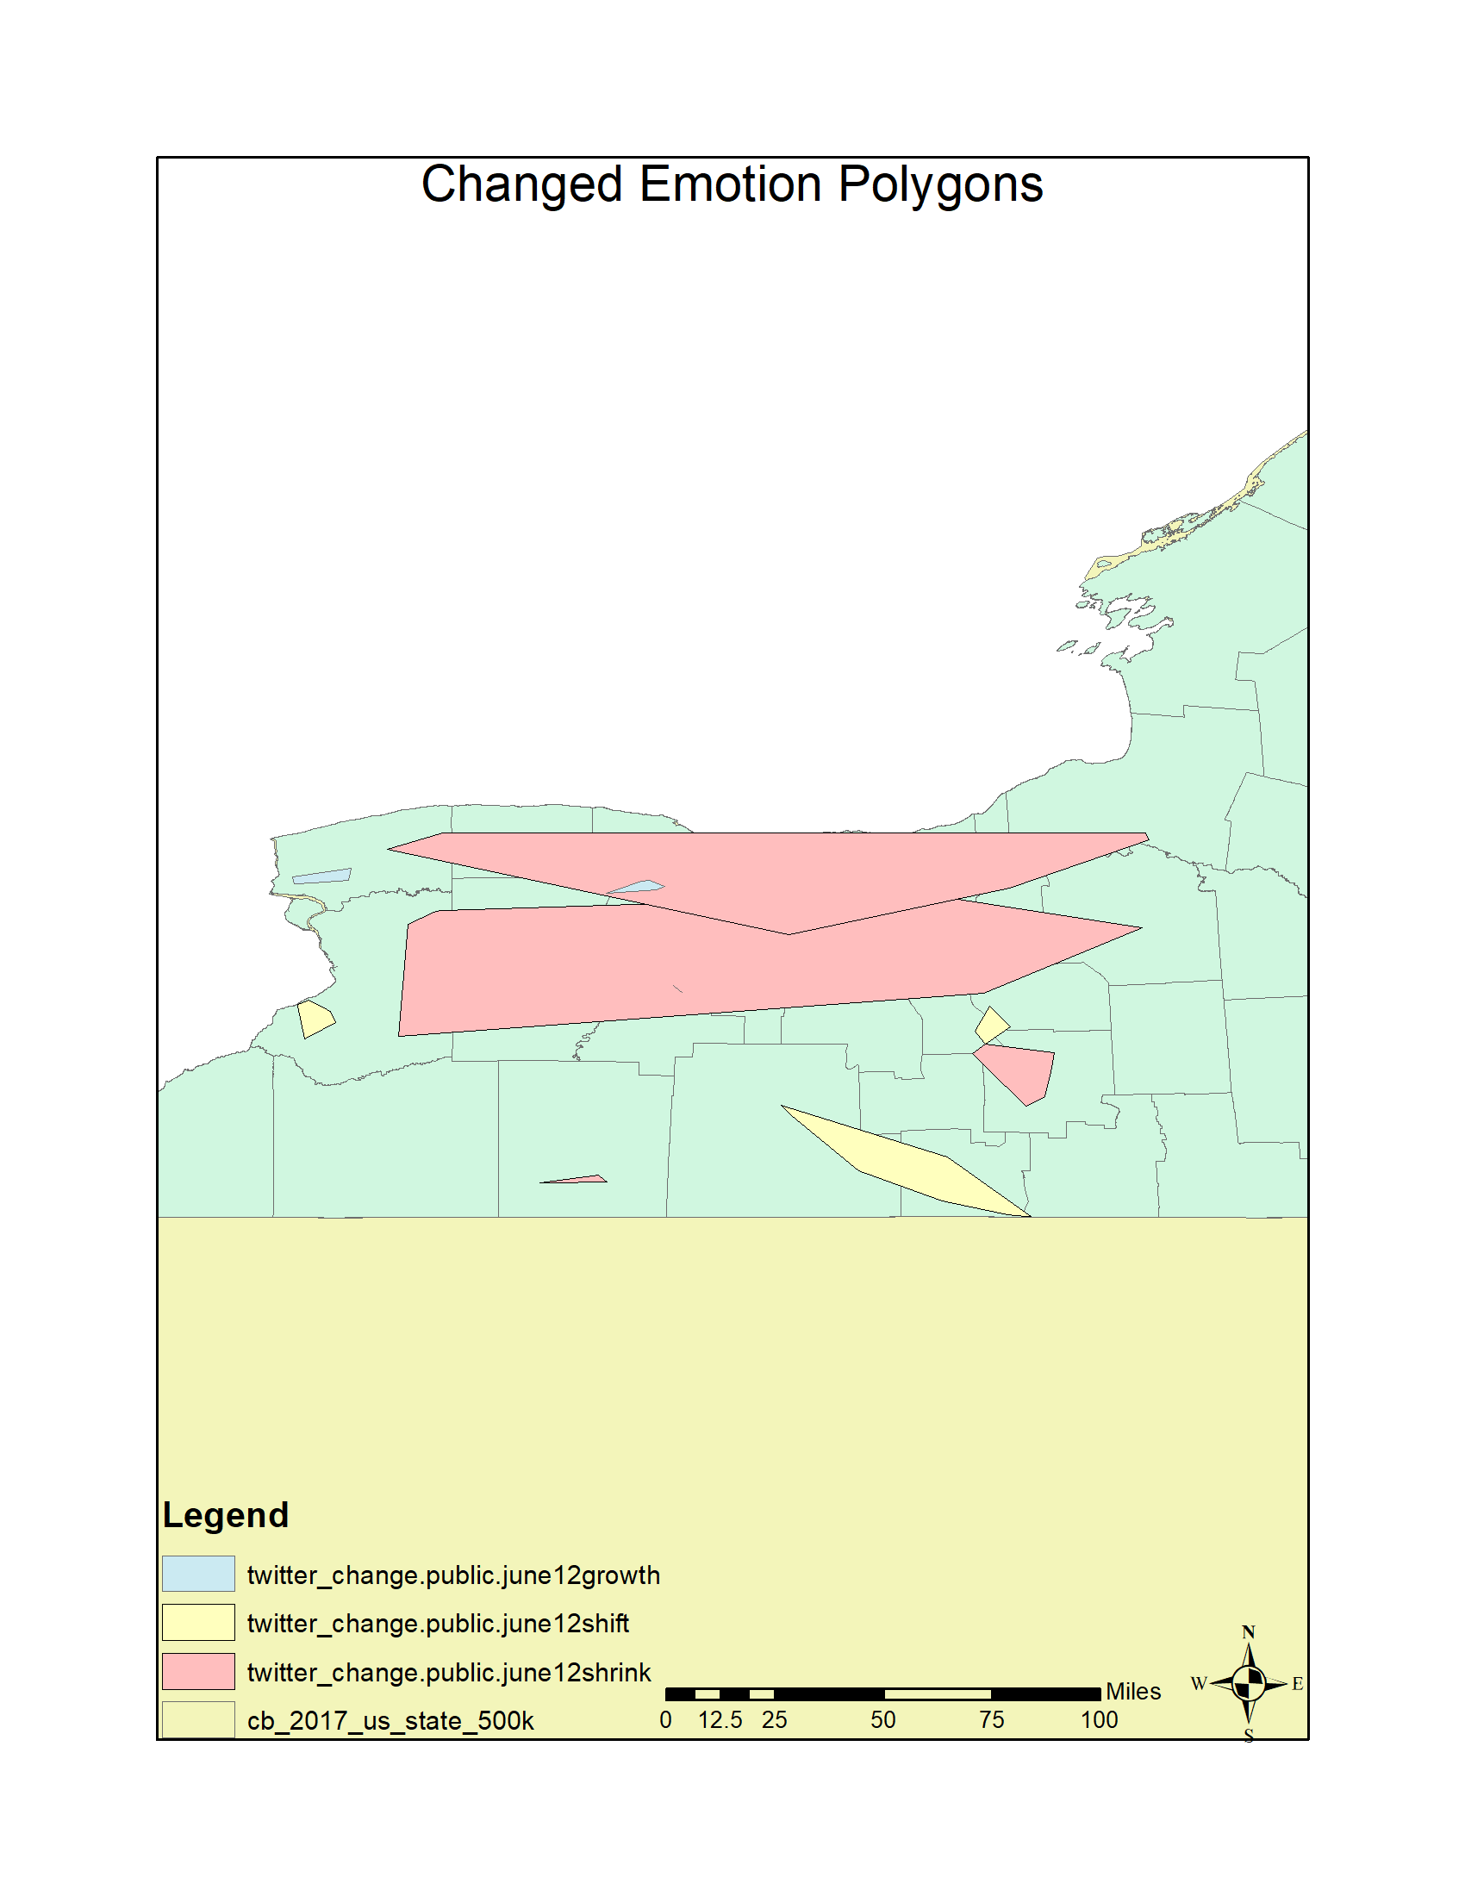

Figure 11 Change in emotion Polygons in New York State

# Conclusion

Our experimental studies show that the change detection and analysis framework can successfully detect changes in land use spatiotemporal datasets.

We will work on the creating change summaries and stories from the data in future.

### References

1. J. Im and J. Jensen. 2005. A change detection model based on neighborhood correlation image analysis and decision tree classification. *Remote Sensing of Environment* 99, 3 (2005), 326–340. DOI:http://dx.doi.org/10.1016/j.rse.2005.09.008
2. Suming Jin, Limin Yang, Patrick Danielson, Collin Homer, Joyce Fry, and George Xian. 2013. A comprehensive change detection method for updating the National Land Cover Database to circa 2011. *Remote Sensing of Environment* 132 (May 2013), 159–175. DOI:http://dx.doi.org/10.1016/j.rse.2013.01.012
3. D. Lu, P. Mausel, E. Brondízio, and E. Moran. 2004. Change detection techniques. *International Journal of Remote Sensing* 25, 12 (June 2004), 2365–2401. DOI:http://dx.doi.org/10.1080/0143116031000139863
4. Merrill K. Ridd and Jiajun Liu. 1998. A Comparison of Four Algorithms for Change Detection in an Urban Environment. *Remote Sensing of Environment* 63, 2 (1998), 95–100. DOI:http://dx.doi.org/10.1016/s0034-4257(97)00112-0
5. S. Minu and Amba Shetty. 2015. A Comparative Study of Image Change Detection Algorithms in MATLAB. *Aquatic Procedia* 4 (March 2015), 1366–1373. DOI:http://dx.doi.org/10.1016/j.aqpro.2015.02.177